- Start minikube
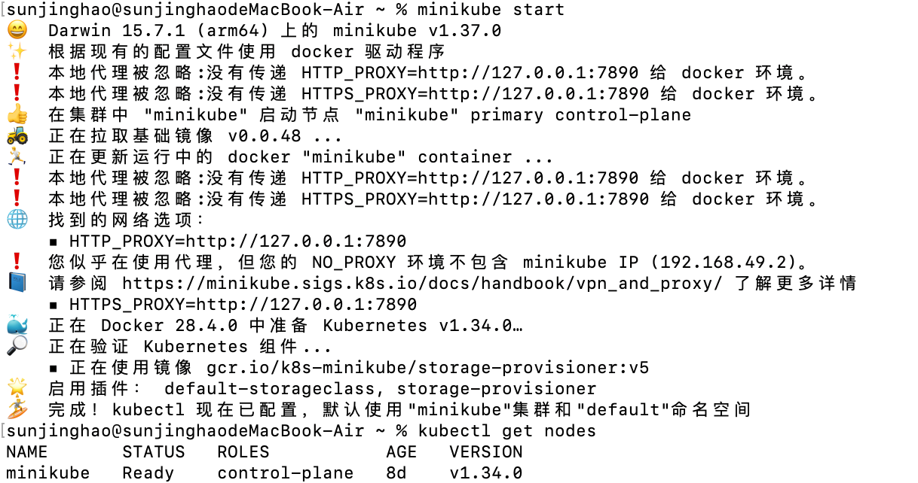

- Confirm kubernet is ready
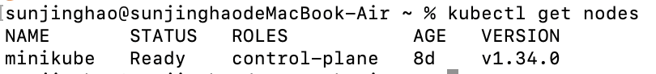

- Install Knative Serving
- Install Serving CRDs
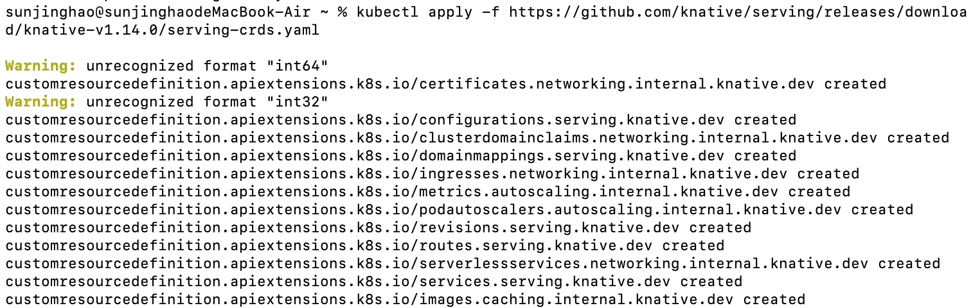

- Install Serving Core
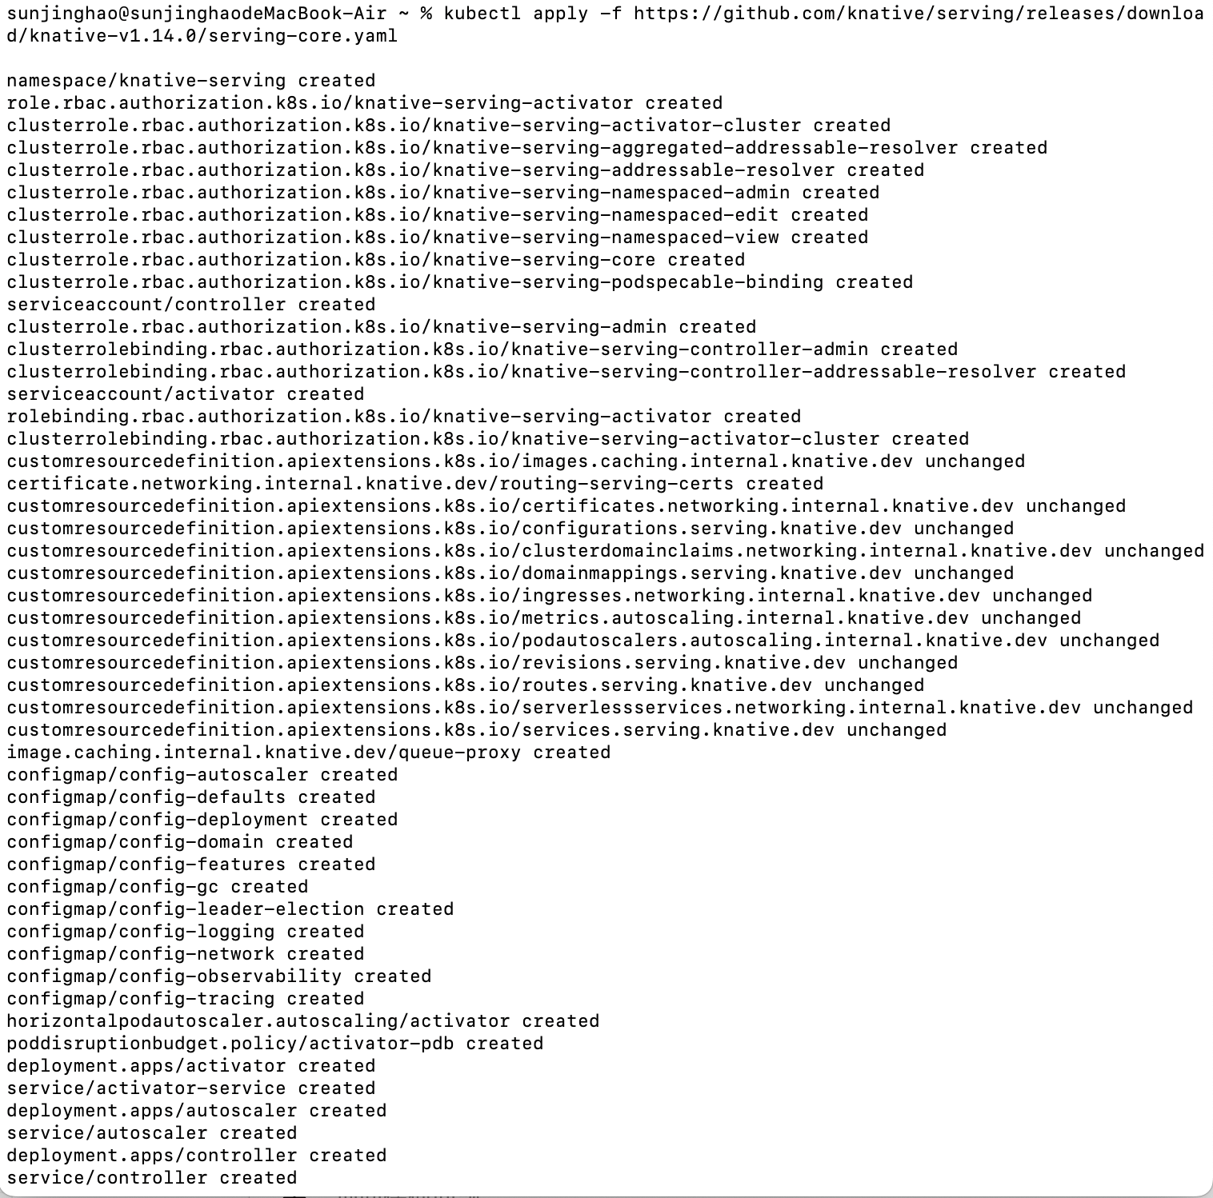

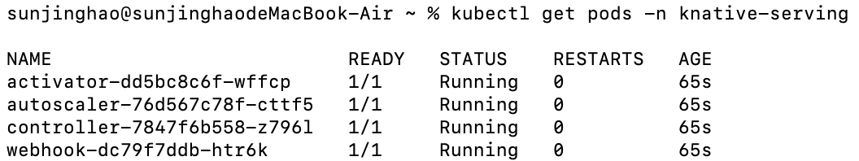

- Install lstio
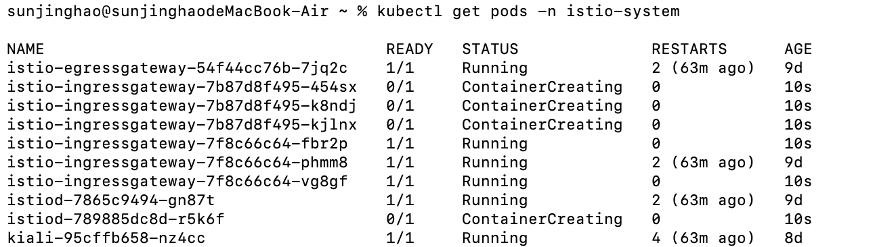
- Install net-lstio
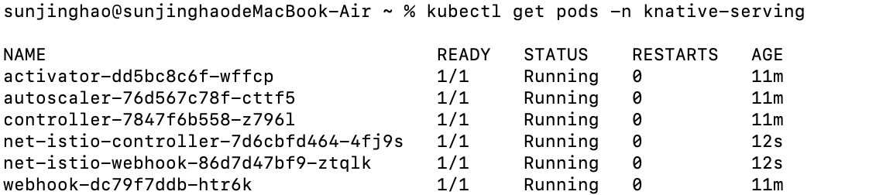
- Get lstio Ingress Gateway
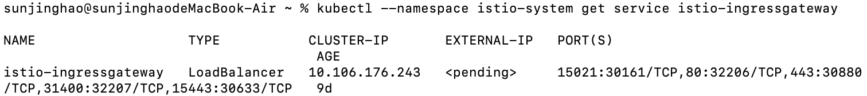

- Install Cert-Manger
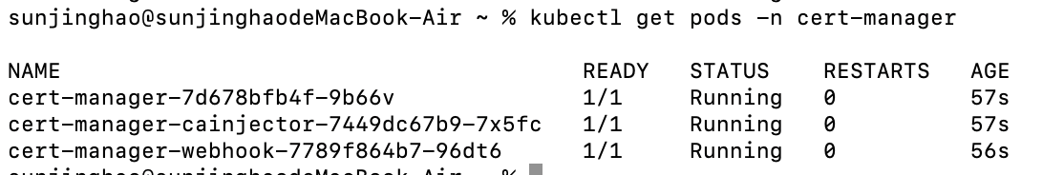

- Install Knative Eventing
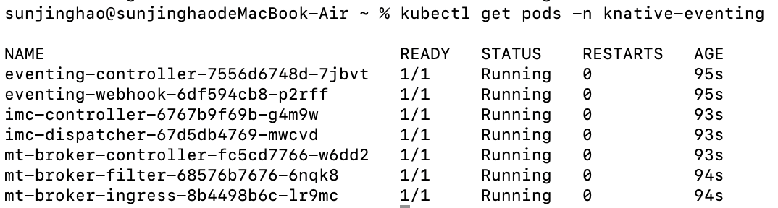

- Knative Founctions
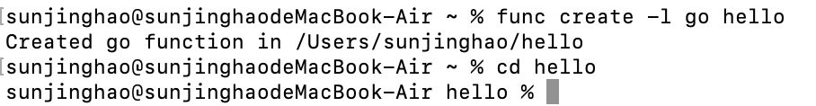
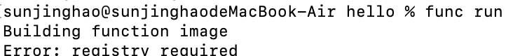
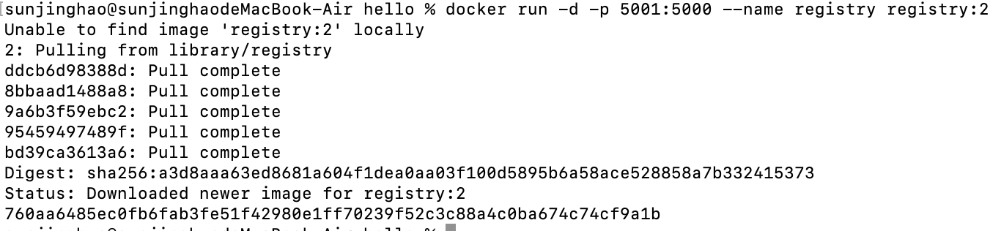
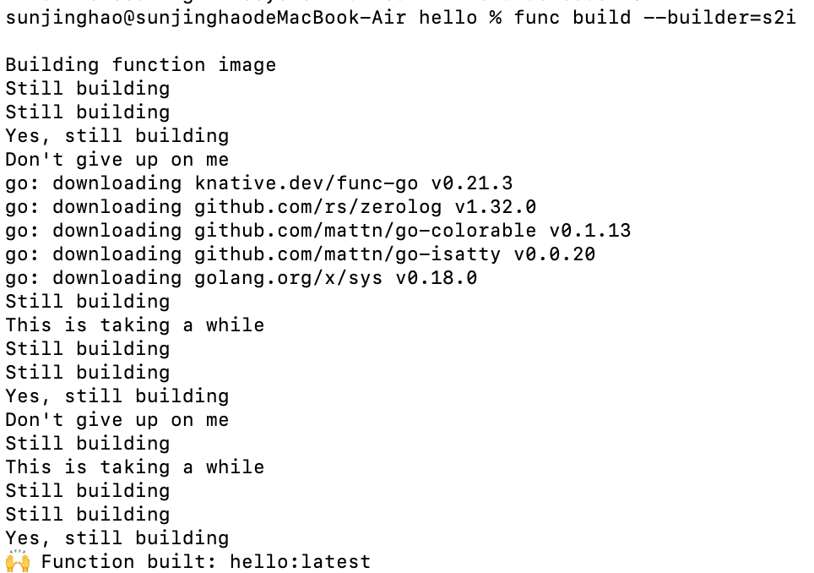
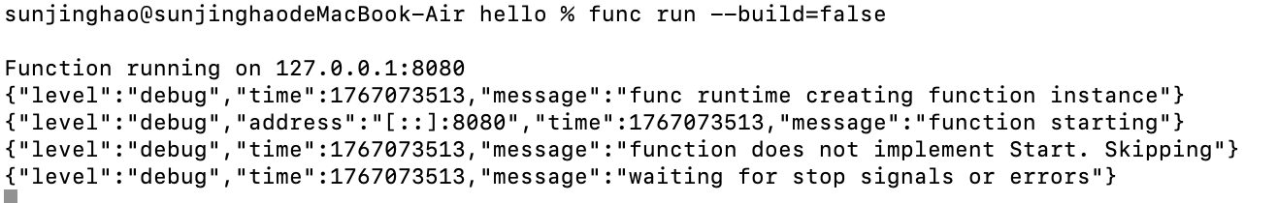

- Knative Serving
